**.gitignore**

Is this a typical template? I google this & it was a copy of someone’s else gig ignore.

**Example Usage of the Module**

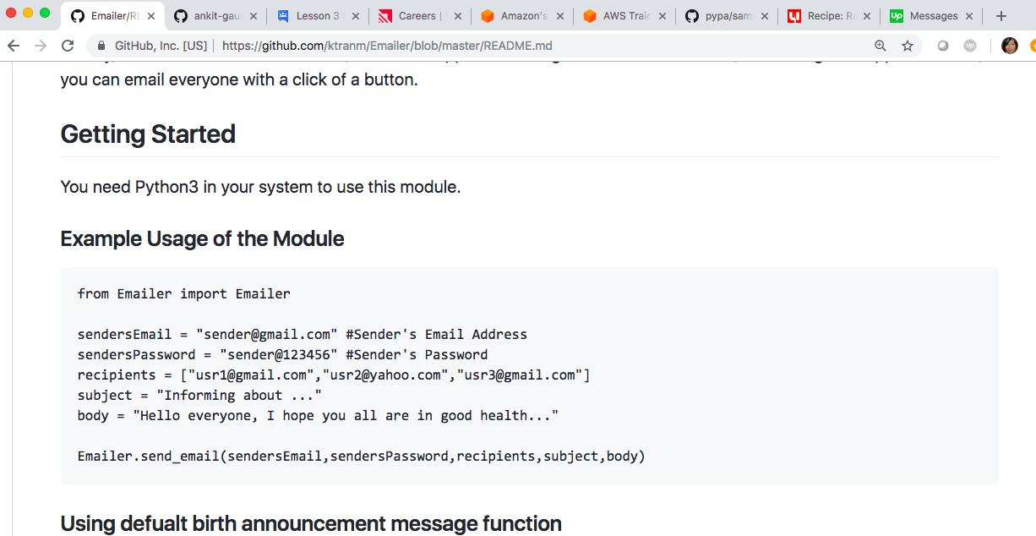

From here on out, let’s make sure we have the same format for everything. For some reason, depending on the document, things are different.

This is the format, I would like to see for the following:

user_name1@gmail.com, user_name2@gmail.com, user_name3@gmail.com

recipient1@gmail.com, recipient2@gmail.com, recipient3@gmail.com

**Birth Announcement:**

childName = "Emma Smith"

date = "January 15, 2016"

time = "11:00 AM"

weight = "8 pounds, 7 ounce"

height = "11 inches"

Using default birth announcement message

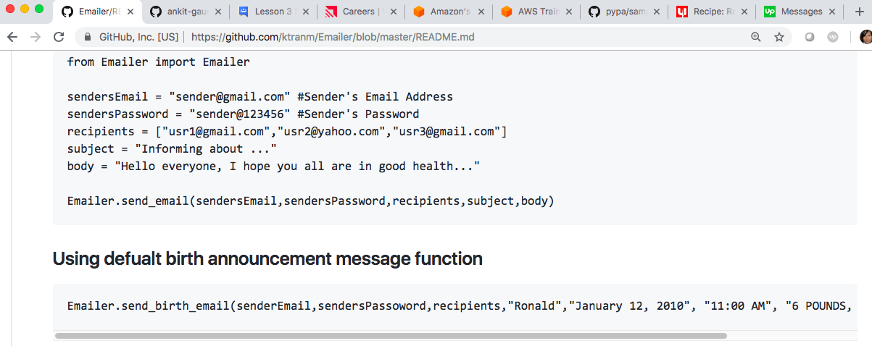

**Birth Announcement:**

childName = "Emma Smith"

date = "January 15, 2016"

time = "11:00 AM"

weight = "8 pounds, 7 ounce"

height = "11 inches"

**Please delete input.txt**

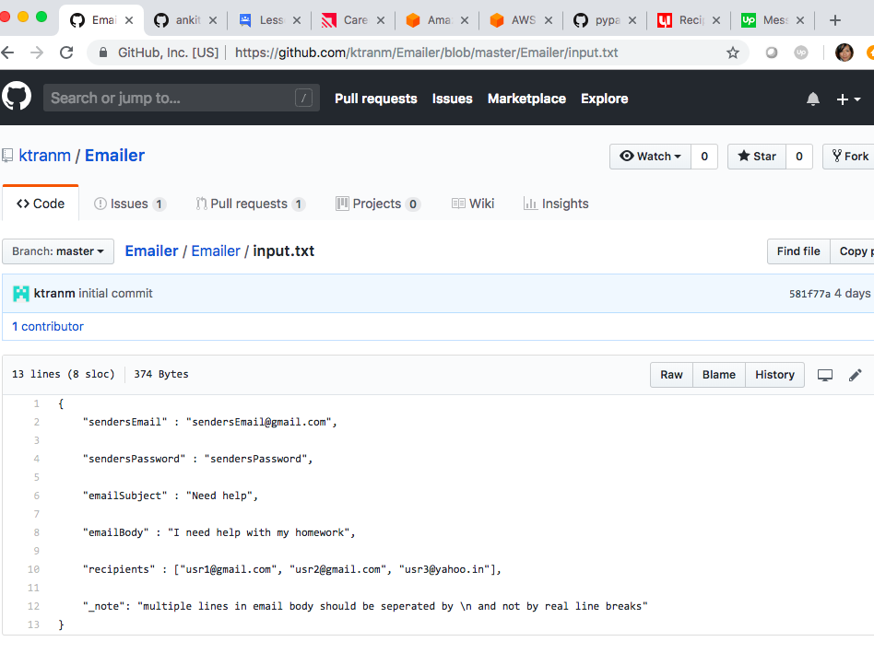

Please change the following under this Notebook:

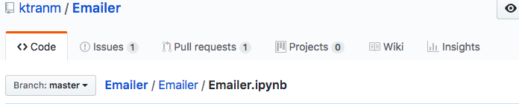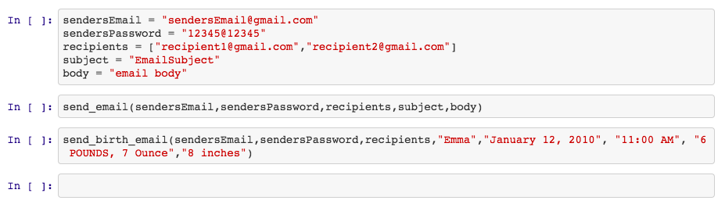

subject = “email subject”

body = “email body”

**Birth Announcement:**

"Emma Smith"

"January 15, 2016"

"11:00 AM"

"8 pounds, 7 ounce"

"11 inches"